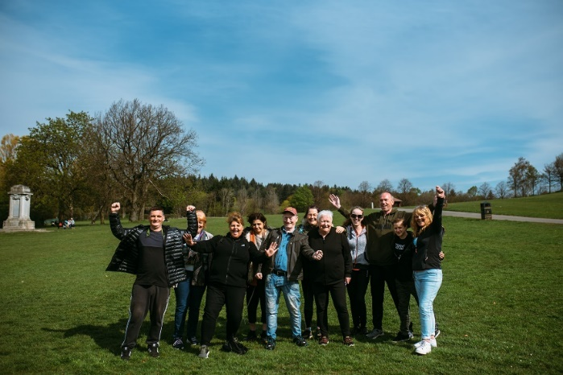




THEMED WALKS – January/February 2026

Our themed walks will discover and explore Renfrewshire's rich heritage. These walks are around 2 hours long and are another level to complement our health walks.

Themed walks MUST be booked by contacting:
healthandwellbeing@renfrewshire.gov.uk or contact Senga 07776 473 814 or Claire 07483 130 065.
Leave your name, contact number, emergency contact and which walk you would like to attend.

January

Tues 13th Blow away the Cobwebs - Join us on this first ramble of 2026.
Meeting:- Castle Semple Visitor Centre, Lochlip Road, Lochwinnoch PA12 4EA at 11.00am

Tues 20th Exploring Renfrew’s Parks - Today we will explore some of this historic Town’s parks.
Meeting:- Inchinnan Road entrance, Roberston Park, Renfrew PA4 8NF at 11.00am

Tues 27th Villages of Renfrewshire – Our walk will take us in and around the village of Brookfield.
Meeting:- Morrisons Main Car Park, Napier Street, Johnstone PA5 8SF at 11.00am

February

Tues 3rd Paisley Parade – A walk through the Town and along the White Cart.
Meeting:- Outside Paisley Abbey, Abbey Close PA1 1JG at 11.00am

Tues 10th Linwood Moss - Discover Linwood Community Woodland and this section of the Gryffe
Valley Way.
Meeting:- Linwood ON-X, Brediland Road, Linwood PA3 3RA at 11.00am

Tues 17th Renfrew Esplanade – Enjoy a stroll along the River Clyde on Renfrew’s very own esplanade.
Meeting:- Outside Sainsbury’s, Braehead, Kings Inch Dr, Glasgow G51 4BT at 11.00am

Tues 24th Levern Walkway and Cowan Park – Step over the boundary into the East Renfrewshire
town of Barrhead.
Meeting:- Barrhead Railway Station, Carlibar Road, G78 1AA at 11.00am

Culture, leisure and sport.
We are OneRen.
oneren.org #WeAreOneRen @weareoneren

