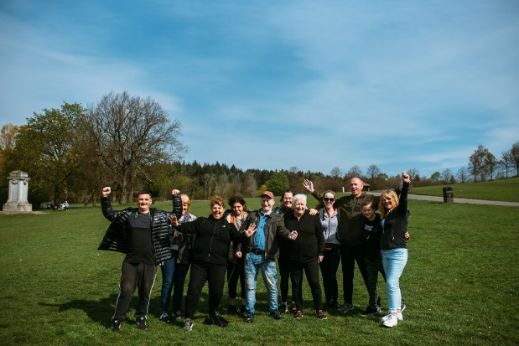

**HEALTH WALKS**

Come along and join us on our **FREE** weekly health walks around the Renfrewshire area.

A health walk is a short, low level flat walk suitable for all levels of ability.

Health walks usually last around 30-60mins (unless otherwise stated) and there is no need to book these, just arrive at the designated place and time and tell the walk leader you are new!

Any queries please don’t hesitate to contact Senga:

Email - [healthandwellbeing@renfrewshire.gov.uk](mailto:healthandwellbeing@renfrewshire.gov.uk)

Phone - 07776 473 814

**MONDAY**

Renfrew

Time: 2.15pm

Meet: Retail Park off Inchinnan Rd

(next to Renfrew Juniors Carpark)

**TUESDAY**

Paisley

Time: 5.15pm

Meet: Paisley Abbey

(main entrance)

**THURSDAY**

Paisley

Time: 10.30am

Meet: Barshaw Park

(at notice board across from café)

**TUESDAY**

Paisley

Time: 10.30am

Meet: Paisley Abbey

(main entrance)

**WEDNESDAY**

**30-40 min walk**

Paisley

Time: 12.15pm

Meet: Lagoon Leisure Centre

(main entrance)

**THURSDAY**

Paisley

Time: 12.30pm

Meet: Barshaw Park

(at notice board across from café)



**!!! Please note on the last Thursday of the month our Barshaw Park walks meet outside Paisley Abbey!!!**

Culture, leisure and sport.

We are OneRen.

oneren.org #WeAreOneRen @weareoneren