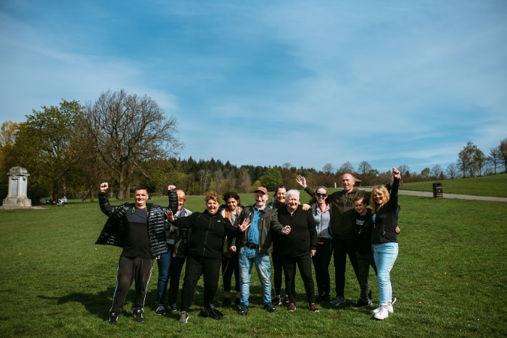

**THEMED WALKS – JULY - AUGUST**

Our themed walks will discover and explore Renfrewshire's rich heritage and nature. These walks are 1.5-2 hours long and are another level to complement our health walks.

Themed walks **MUST** be booked by contacting:

[healthandwellbeing@renfrewshire.gov.uk](mailto:healthandwellbeing@renfrewshire.gov.uk) or contact Senga 0798 242 8157 or Claire 07483 130 065.

**Leave your name, contact number, emergency contact and which walk you would like to attend.**

**JULY**

**Tues 29th** **Three Paisley Parks**

A trio of Paisley Parks to explore along this paved linear route.

**Meeting at the Charleston Centre, Neilston Road at 11.00am**

**AUGUST**

**Tues 5th Fae Johnstone’s Toon to Habbies Kilbarchan**

A wee wander along the cycle track to Kilbarchan where we will explore this weaver village.

**Meeting at Morrison’s Main Car park at 11.00am**

**Tues 12th Erskine Jaunt**

Enjoy this flat riverside walk along the Clyde

**Meeting at Erskine Swimming Pool (Bridgewater Shopping Centre) at 11.00am**

**Tues 19th**  **Paisley Historical Adventure**

Discover Paisley - The Old & New - may have short inclines on this paved route.

**Meeting at Paisley Abbey, at 11.00am**

**Tues 26th Renfrew Along & Over To Yoker**

Today we will try, at last, to cross the border and walk across the water via the new bridge.

**Meeting at Renfrew Town Hall, at 11.00am**



Culture, leisure and sport.

We are OneRen.

oneren.org #WeAreOneRen @weareoneren