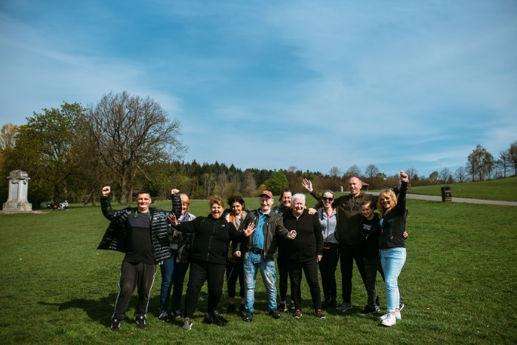

THEMED WALKS – March/April 2024

Our themed walks will discover and explore Renfrewshire's rich heritage. These walks are around 2 hours long and are another level to complement our health walks.

Themed walks MUST be booked by contacting:
healthandwellbeing@renfrewshire.gov.uk or contact Senga 07776 473 814 or Claire 07483 130 065.
Leave your name, contact number, emergency contact and which walk you would like to attend.

March

Tues 5th Erskine Waterfront – Explore the beach & Boden Boo Woods
Meeting at Erskine Sports Centre, Kilpatrick Drive, Erskine at 11.00am

Thur 21st Langbank – Wander around the picturesque settlement on the Clyde
Meeting at Langbank Train station at 11.00am

Wed 27th Howwood – A countryside walk to Kenmure hill and part of the Semple Trail
Meeting at Howwood Village Hall, Station Road, Howwood at 11.00am

April

Thur 4th Lochwinnoch – Wander around the local regional park and more of the Semple trail
Meeting at Castle Semple Visitor Centre, Lochlip Rd, Lochwinnoch at 11.00am

Fri 12th Bridge of Weir – Explore part of the newly formed Gryffe Valley Way
Meeting at Bridge of Weir Library, Lintwhite Crescent, Bridge of Weir at 11.00am

Tues 16th Linwood – Venture around Linwood Moss and another section of the Gryffe Way
Meeting at Linwood ON-X Sports Centre, Brediland Rd, Linwood at 11.00am

Mon 22nd Glennifer Braes – Wander around the spring meadow up the Braes (hills)
Meeting at Glenburn Community Centre, Fairway Avenue, Paisley at 11.00am

Tues 30th Johnstone Bluebell Woods – Explore the Bluebell Woods in bloom (hopefully!!)
Meeting at Johnstone Community Hub, Beith Rd, Johnstone at 11.00am

Culture, leisure and sport.
We are OneRen.
oneren.org #WeAreOneRen @weareoneren

