**A Trip to Eden Court**

**to see Treasure Island**

Going to see Treasure Island

at Paisley Arts Centre

**1**. I am going to Paisley Arts Centre to see a play called Treasure Island.

* I will visit Paisley Arts Centre, which is a building in Paisley where people go to see live performances and music shows.

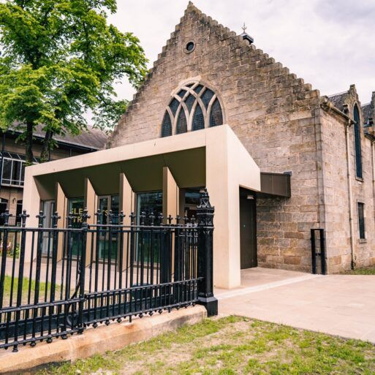

* Today, I am going to see a play. A play is like a movie, but with real people acting on stage.

**2**. Treasure Island is the name of the play I will watch.

* It’s about a young boy named Robbie who reads a book about Jim Hawkins. Jim is a boy who finds a treasure map. He goes on an adventure to find treasure!

* There will be pirates, a ship, a parrot and a big bed that turns into a ship in the story.

**3**. Before the play starts, I will travel to Paisley Arts Centre.

* I might travel there with my teacher and my friends on a bus.
* When I arrive, I will see the Paisley Arts Centre building. It is large and looks like a church.

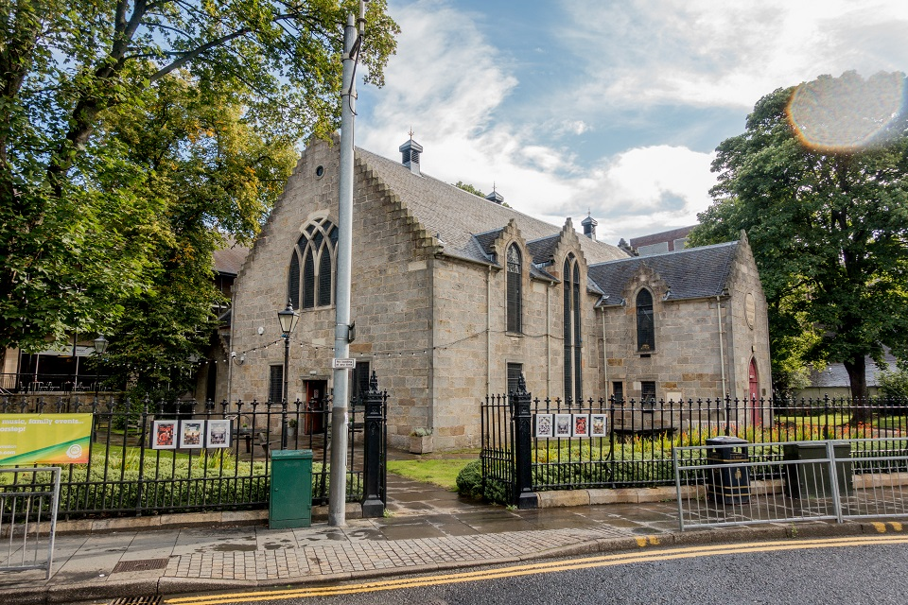

**4**. When I enter Paisley Arts Centre, I will see different people.

* There will be people selling tickets. I might wait in line to get my ticket.
* My teacher and my friends will be with me, and I will stay close to them.

**5**. After we have our tickets, we will go inside the theatre.

* The theatre is a big room with lots of seats.

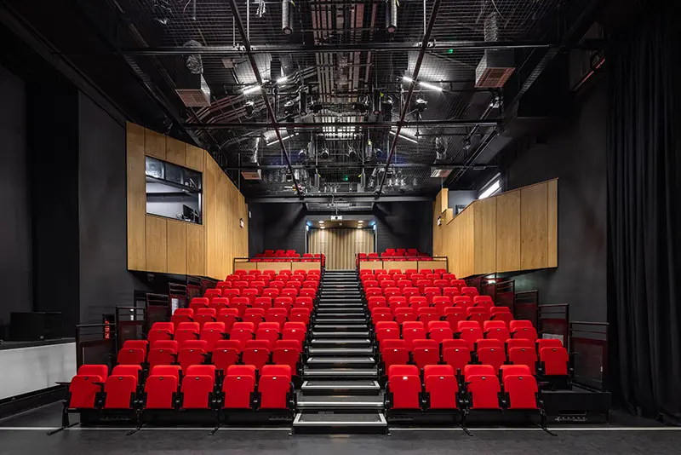

* I will find my seat and sit down. It’s important to sit quietly while waiting for the show to start.

**6**. When the play begins, the lights will get dim.

* This means the show is starting. I might hear music or see the actors walk on stage.
* It might get a little dark, but that’s okay. It makes the play more exciting!

**7**. The actors will pretend to be the characters from Treasure Island.

**Who I will see in the play**

Anthony O’Neill plays Robbie and Jim Hawkins.

Stephanie MacGaraidh plays lots of characters.

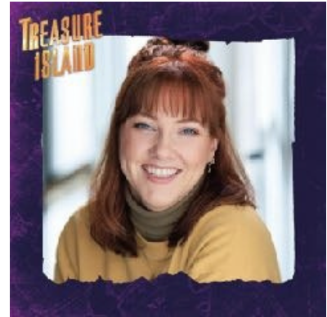

Megan McGuire plays lots of characters.

Simon Donaldson plays lots of characters.

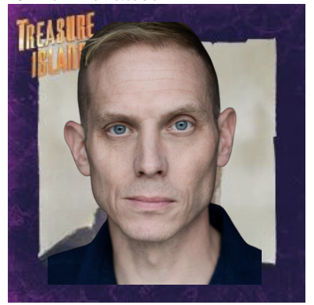

* Robbie will be a boy who reads a book about Jim Hawkins. Jim wants to find the treasure.
* Long John Silver is a pirate, and he might have a funny voice.
* There will be four actors on the stage. Sometimes the same actor will be pretending to be a different character. I will know that they are a different character because their costume will change, and they will use a different voice.
* I can watch the actors and listen to the story and to the music.

**8**. During the play, I can clap if I like something.

* Sometimes people clap during the show to say they like it. I can clap too if I want.
* If I feel like I need a break, I can tell my adult, and we can step outside for a few minutes.

**9**. The play will have a break in the middle.

* This is called an "interval." We can get up, stretch, and maybe have a snack.
* Then, we will return to our seats to watch the second part of the play.

**10**. At the end of the play, everyone will clap for the actors.

* When the play is over, the actors will come out and bow. This is called "taking a bow."
* I can clap to show them that I enjoyed the play.

**11**. After the play, I will leave the theatre with my teacher and my friends.

* We will walk out of Paisley Arts Centre, talking about the fun things we saw in the play.
* I might feel happy and excited after watching Treasure Island.

**12**. Going to Paisley Arts Centre to see Treasure Island is a fun experience.

* I will see an exciting story, listen to some good music, watch great acting, and have a fun time with my friends.

**What else might I need to know?**

There will be some loud noises in the play.

There will be one gunshot noise, which will be loud.

**Content warning:**

Sometimes I will see the actors fighting, don’t

worry this is not real, they are pretending.

In the story some of the characters are killed. This

is not real, they are just pretending.

In the story a building is set on fire, this is not real, and nobody gets hurt.