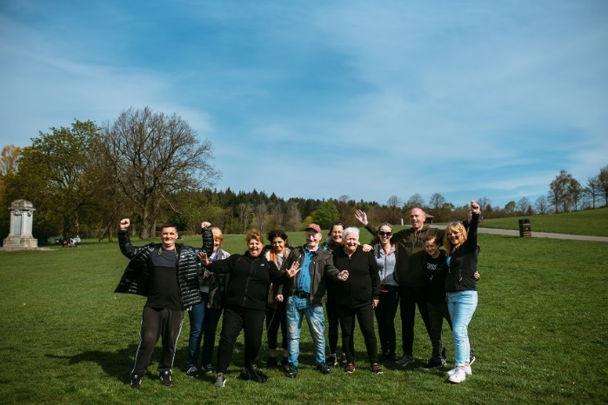

**THEMED WALKS – Jan/Feb 2025**

Our themed walks will discover and explore Renfrewshire's rich heritage. These walks are around 2 hours long and are another level to complement our health walks.

Themed walks **MUST** be booked by contacting:

healthandwellbeing@renfrewshire.gov.uk or contact Senga 07776 473 814 or Claire 07483 130 065.

**Leave your name, contact number, emergency contact and which walk you would like to attend.**

**Jan**

**Thurs 9th** **New Year, New walk –** Walk along the completed Renfrew/Paisley link

Meeting at 11.00am at County Square, Paisley

**Fri 17th Ralston Wander –** Explore the area towards Rosshall Park

Meeting at 11.00am at Barshaw park, outside the cafe

**Tues 21st**  **Brookfield Canter –** Discover the small dormitory village in Renfrewshire

Meeting at 11.00am at Morrisons, Napier St, Johnstone

**Mon 27th Paisley’s Bard –** Explore the legacy of Tannahill whilst sauntering around Paisley

Meeting at 11.00am at Paisley Town Hall

**Feb**

**Tues 4th Erskine Waterfront –** Wander along the Clyde walkway towards Boden Boo Woods.

Meeting at 11.00am at Erskine Sports Centre, Kilpatrick Drive, Erskine.

**Wed 12th Glenburn ramble –** Discover the Paisley/Barrhead link along the Glennifer Braes.

Meeting at 11:00am at Glenburn Community Centre, Fairway Ave, Glenburn.

**Fri 21st Bishopton Plod –** Explore the area towards Mar Hall and the Clyde.

Meeting at 11.00am at Bishopton Library, Greenock Road, Bishopton.

**Thurs 27th Renfrew/Yoker Bridge –** Wander over the new bridge (fingers crossed) and discover the area. Meeting at 11.00am at Renfrew Town Hall.



Culture, leisure and sport.

We are OneRen.

oneren.org #WeAreOneRen @weareoneren