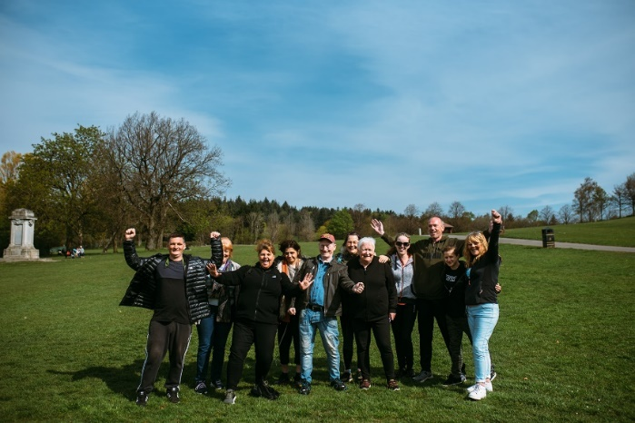




THEMED WALKS – November/December 2025

Our themed walks will discover and explore Renfrewshire's rich heritage. These walks are around 2 hours long and are another level to complement our health walks.

Themed walks MUST be booked by contacting:
healthandwellbeing@renfrewshire.gov.uk or contact Senga 07776 473 814 or Claire 07483 130 065.
Leave your name, contact number, emergency contact and which walk you would like to attend.

November

Tues 4th Woodlands of Johnstone - Join us on this ramble through the Rannoch and Bluebell Woods.
Meeting at 11.00 at Johnstone Railway Station.

Tues 11th Linwood - What’s in a name? A wander around Linwood taking in the Black Cart Water.
Meeting at 11.00am outside the Tweedie Halls, Bridge St, PA3 3DB

Tues 18th Swan-ing around Durrockstock Park Local Nature Reserve and beyond. We will explore this refuge for wildlife within the postwar housing scheme of Foxbar.
Meeting at 11.00am Foxbar Library, Ivanhoe Road, PA2 0LA

Tues 25th Villages of Renfrewshire – Today we will have a stroll around the villages of Houston and Crosslee.
Meeting at 11.00am at The Carrick Centre, Main St, Houston PA6 7HD

December

Tues 2nd Erskine Waterfront – Wander along the Clyde Walkway towards Newshot Island Local Nature Reserve.
Meeting at 11.00am outside Erskine Swimming Pool, Bridgewater Shopping Centre, Erskine.

Tues 9th Villages of Renfrewshire - A walk around Howwood with views over to the Hill of Stake.
Meet at 11.00am at the Village Hall, Station Road PA9 1BB.

Tues 16th Festive Delights – Get into the Christmas spirit as we step out around Paisley.
Meeting at 11.00am at Paisley Town Hall.

Culture, leisure and sport.
We are OneRen.
oneren.org #WeAreOneRen @weareoneren

