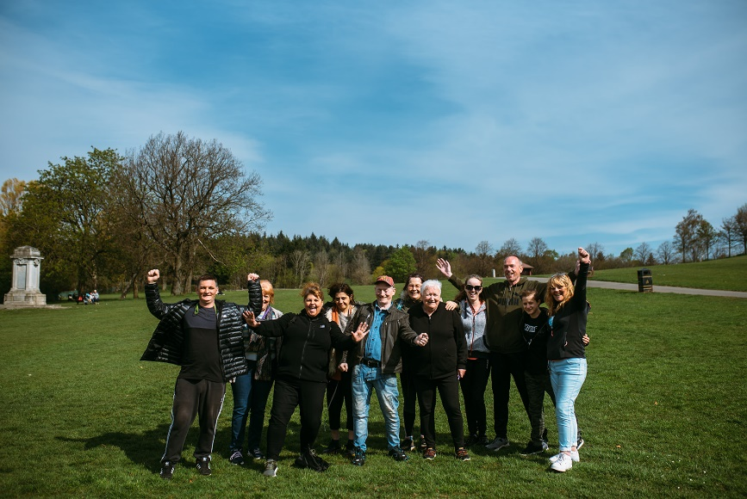

HEALTH WALKS – March & April 24

Come along and join us on our FREE weekly health walks around the Renfrewshire area.
A health walk is a short, low level flat walk suitable for all levels of ability.

Health walks usually last around 30-60mins (unless otherwise stated) and there is no need to book these, just arrive at the designated place and time and tell the walk leader you are new!

Any queries please don’t hesitate to contact Senga:
Email - healthandwellbeing@renfrewshire.gov.uk
Phone - 07776 473 814

Every Tuesday Paisley Town Centre and the surrounding areas
Meeting at Paisley Abbey at 10.30am

Every Wednesday Lagoon Health Walk
This is low level day - a 20–30 minute walk around the local area
Meeting at the Lagoon Leisure Centre (inside main entrance) at 12.15pm

Every Thursday Barshaw Park
Meeting at 10.30am at the notice board across from the café

Meeting at 12.30pm at the notice board across from the café
Please note this is a slower easier paced walk and is an all ability walk.

!!! On the last Thursday of the month both our Barshaw Park walks will meet at Paisley Abbey !!!

Join us as we discover Paisley, old and new, as we wander around this historical town.
Meeting at 10.30am outside Paisley Abbey
Meeting at 12.30pm outside Paisley Abbey (slower paced walk)

Culture, leisure and sport.
We are OneRen.
oneren.org #WeAreOneRen @weareoneren

