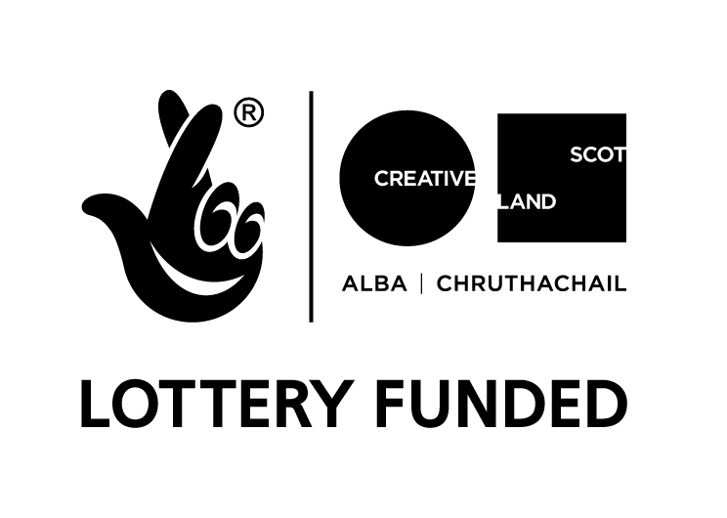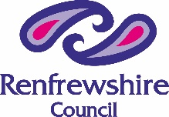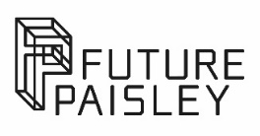

Freelance Creative Networks Promoter
Place Partnership at OneRen.
Equalities Monitoring Form April 2023

Who should complete this form?
The Equalities Monitoring Form is used to give us essential statistical information about who our applicants are, and who we’re funding.

If you have applied to us for funding, we now ask you to also complete this form and submit it along with your application form.
We are committed to offering clear and accessible application processes and programmes that are open to everyone. On request this information is available in alternative formats including translations and access support is available for disabled applicants.
Equalities Monitoring Background

We put equality at the heart of our activity, and we aim to acknowledge and reflect the diversity in Scotland today in all our work.

To monitor the type of applications we receive and the investments we award, we need to collect information which does not directly relate to our assessment of your application. We include questions on age, gender, ethnicity, disability, and sexual orientation - all defined ‘protected characteristics’ in The Equality Act 2010. We also include a question on Gaelic language.

It is important that you provide this information to assist our reporting in line with the above act and to help us to improve our services.

In providing your completed response along with your application form, you are giving explicit consent for us to use this data for statistical reporting. The data is managed confidentially, is not personally attributable, will not have any bearing on your application for funding and is processed in accordance with the Data Protection Act.

If you do not know some of the information or if you prefer not to provide it, you can fill in the 'Prefer not to answer' box.
Please now tell us about yourself. Please mark an X against the relevant boxes, unless asked otherwise.

Age
How old are you?

16-24 years
25-30 years
30-44 years
45-65 years
65+ years
Prefer not to say

Disability
Do you have any of the following conditions which have lasted, or are expected to last, at least 12 months?

Non-disabled
Visual impairment
Hearing impairment/deaf
Physical disabilities
Cognitive or learning disabilities
Mental health condition
Other long term/chronic condition
Other (please specify)
Prefer not to say

Gender
What is your gender?

Male
Female
Other
Prefer not to say

Sexual Orientation

Which of the following options best describes how you think of yourself?

Heterosexual/Straight
Gay/Lesbian
Bisexual
Other
Prefer not to say

Ethnicity
What is your ethnic group? Please indicate which best describes your ethnic group or background.

White Scottish/White British
Irish
Gypsy/Traveller
Polish
White Other (please specify)
Asian/Asian Scottish/Asian British
Chinese/Chinese Scottish/Chinese British
African/African Scottish/African British
Caribbean/Caribbean Scottish/Caribbean British
Black/Black Scottish/Black British
Arab/Arab Scottish/Arab British
Mixed or Multiple Ethnic Groups, please specify:
Other (please specify)
Prefer not to say

Gaelic Language
Do you speak or are you learning Gaelic?

Yes
No
Learning Gaelic

Project focus
If relevant, roughly, what percentage of your application/project has a specific focus on developing the following themes?

Minority ethnic
Disabled people
LGBTI
Gender group
Children and Young People (0-25)
Older People
Faith/Religion
Health/Wellbeing
Not Applicable

Thank you for completing this form.

Please note: The Equalities Monitoring Form is anonymous and will, on receipt, be processed separately from your application. The data is managed confidentially, is not personally attributable, will have no bearing on your application for funding and is processed in accordance with the Data Protection Act.

