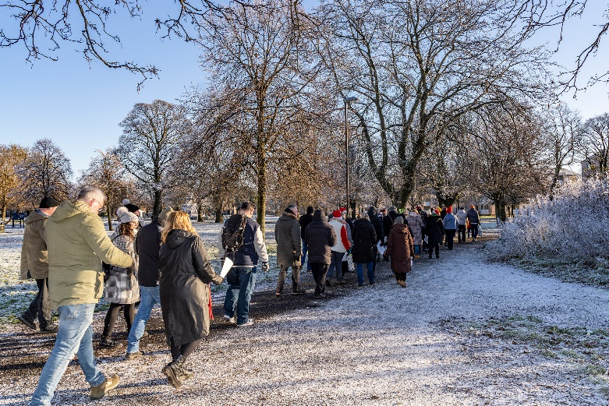

**FESTIVE THEMED WALKS – November & December**

Our themed walks generally discover and explore Renfrewshire's rich heritage. These walks are around 2 hours long and are another level to complement our health walks.

In November and December we will get into the festive mood and deliver 4 seasonal walks, taking in the areas decorations and Christmas lights!

Themed walks **MUST** be booked by contacting:

[healthandwellbeing@renfrewshire.gov.uk](mailto:healthandwellbeing@renfrewshire.gov.uk) or contact Yvonne 07483 335 910 or Claire 07483 130 065.

**Leave your name, contact number, emergency contact and which walk you would like to attend.**

**November**

**Fri 24th****Festive walk - Braehead**

Meeting at Sainsburys, Braehead, G51 4BT, at 11.00am

**Tue 28th Festive walk - Renfrew**

Meeting at Renfrew Town Hall, Renfrew Cross, PA4 8PF, at 11.00am

**December**

**Wed 6th** **Festive walk - Johnstone**

Meeting at Johnstone Town Hall, Church Street, PA5 8EG, at 11.00am

**Thur 14th** **Festive walk - Paisley**

Meeting at Lagoon Leisure Centre, Paisley, PA1 1NB, at 11.00am



Culture, leisure and sport.

We are OneRen.

oneren.org #WeAreOneRen @weareoneren