
ONEREN HEALTH WALKS

ENTRY LEVEL HEALTH WALKS
LOW LEVEL FLAT WALKS LASTING APPROX 30 MINS


GENERAL LEVEL HEALTH WALKS
LOW LEVEL FLAT WALKS LASTING APPROX 60 MINS

WEDNESDAY
Linwood
Time: 11.00am
Meet: On-X Leisure Centre
(main entrance)

WEDNESDAY
Johnstone
Time: 12.15pm
Meet: Thomas Shanks Park
(carpark near the bus stop)

WEDNESDAY
Paisley
Time: 12.15pm
Meet: Lagoon Leisure Centre
(Health & Wellbeing Hub)

MONDAY
Renfrew
Time: 2.15pm
Meet: Retail Park off Inchinnan Road
(next to Renfrew Juniors Carpark)

TUESDAY
Paisley
Time: 10.30am
Meet: Paisley Abbey
(main entrance)

TUESDAY
Paisley
Time: 5.15pm
Meet: Paisley Abbey
(main entrance)

THURSDAY
Paisley
Time: 10.30am
Meet: Barshaw Park
(at notice board across from cafe)

THURSDAY
Paisley
Time: 12.30pm
Meet: Barshaw Park
(outside the café)

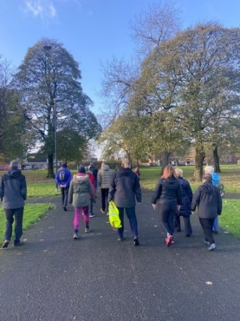
FREE!
No need to book, just turn up at the designated meeting place.
Dress for the weather!
Any queries contact Senga:
Email—healthandwellbeing@renfrewshire.gov.uk
Phone—07776 473 814

