
ONEREN HEALTH WALKS

ENTRY LEVEL HEALTH WALKS
LOW LEVEL FLAT WALKS LASTING APPROX 30 MINS


GENERAL LEVEL HEALTH WALKS
LOW LEVEL FLAT WALKS LASTING APPROX 60 MINS

WEDNESDAY
Linwood
Time: 11.00am
Meet: On-X Leisure Centre
(main entrance)

WEDNESDAY
Johnstone
Time: 12.15pm
Meet: Thomas Shanks Park
(carpark near the bus stop)

WEDNESDAY
Paisley
Time: 12.15pm
Meet: Lagoon Leisure Centre
(Health & Wellbeing Hub)

MONDAY
Renfrew
Time: 2.15pm
Meet: Retail Park off Inchinnan Road
(next to Renfrew Juniors Carpark)

TUESDAY
Paisley
Time: 10.30am*
Meet: Paisley Abbey
(main entrance)
*9.30am on the last Tues of the month!!

TUESDAY
Paisley
Time: 5.15pm
Meet: Paisley Abbey
(main entrance)

THURSDAY
Paisley
Time: 10.30am
Meet: Barshaw Park
(at notice board across from cafe)

THURSDAY
Paisley
Time: 12.30pm
Meet: Barshaw Park
(outside the café)

!!! Please note on the last Thursday of the month our Barshaw Park walks meet outside Paisley Abbey!!!

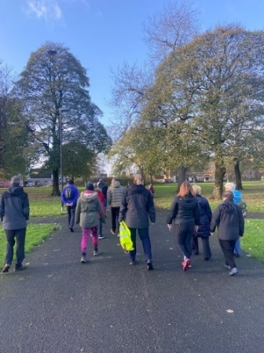
FREE!
No need to book, just turn up at the designated meeting place.
Dress for the weather!
Any queries contact Senga:
Email—healthandwellbeing@renfrewshire.gov.uk
Phone—07776 473 814

