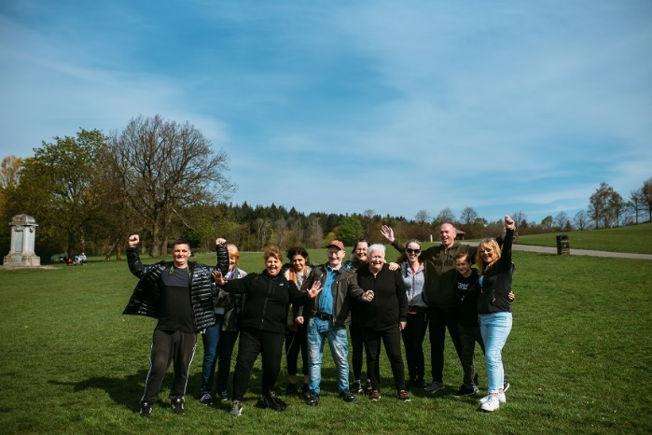

**THEMED WALKS – September/October 2025**

Our themed walks will discover and explore Renfrewshire's rich heritage. These walks are around 2 hours long and are another level to complement our health walks.

Themed walks **MUST** be booked by contacting:

healthandwellbeing@renfrewshire.gov.uk or contact Senga 07776 473 814 or Claire 07483 130 065.

**Leave your name, contact number, emergency contact and which walk you would like to attend.**

**September**

**Tues 2nd** **Johnshill, Lochwinnoch and beyond**

Meeting at 11.00 at Castle Semple Visitor Centre, Lochwinnoch

**Tues 9th The White Cart Wander –** Explore the area towards Rosshall Park

Meeting at 11.00am at junction of Hawkhead Road and NCR 75

**Tues 23rd**  **Gleniffer Braes Country Park –** Enjoy a ramble through Paisley’s own Country Park. This walk will be hilly in places.

Meeting at 11.00am at Glen Lodge, Glenfield Road, Paisley PA2 8TE

**Tues 30th Paisley to Renfrew Link–** Exploring the link path between Paisley and Renfrew.

Meeting at 11.00am at Paisley Town Hall

**October**

**Tues 7th The Golf Courses of Bridge of Weir -** A wander around this Renfrewshire Village.

Meeting at 11.00am outside the Co-op, Main Street, Bridge of Weir.

**Thurs 16th Woodlands of Johnstone.** Join us on this ramble through the Rannoch and Bluebell Woods.

Meeting at 11.00 at Johnstone Railway Station.

**Tues 21st Barshaw Park to Jenny’s Well LNR circular –** From bandstand to local nature reserve and back.

Meeting at 11.00am at the noticeboard near to the café, Barshaw Park

**Tues 28th Elderslie Exploration –** There’s more to this village than William Wallace. Meeting at 11.00am at Elderslie Village Hall, Stoddard Square.



Culture, leisure and sport.

We are OneRen.

oneren.org #WeAreOneRen @weareoneren