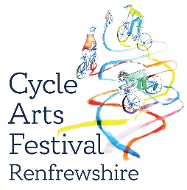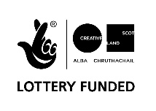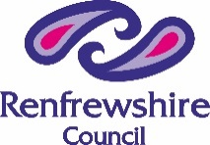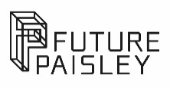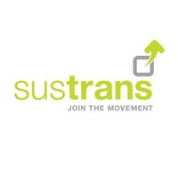

Outdoor Arts & Mixed Media Commissions 2022 Cycle Arts Festival Renfrewshire
Place Partnership at OneRen are pleased to be able to offer a second round of Outdoor Arts Commissions for Renfrewshire Cycle Routes. We are looking for two innovative outdoor Arts installations for presentation along the Paisley to Lochwinnoch cycle route between the 1st and 7th August this year as part of our Cycle Arts Festival 2022.
Funding between £1000 to £5500 is available for Artists or organisations submitting innovative visual / mixed media proposals which meet the Commission Brief.

The Commission Brief:
Our Cycle Paths in Renfrewshire have renewed significance since the COVID-19 lockdown and we are aiming to celebrate their unique value as open spaces which can be enjoyed by everyone, promoting wellbeing and giving access to green space and wild land.
The Renfrewshire Place Partnership is seeking to commission significant outdoor installations for our next Cycle Arts Festival which push boundaries of experimentation and capture distinctive narratives of place for Renfrewshire.
We are specifically but not solely interested in projects that reflect on climate adaptation / celebrate cycling and green transport while capturing wide ranging Contemporary themes, work could reflect on our experience of lockdown and the COVID 19 pandemic or celebrate the unique outdoor environments in Renfrewshire. We are open to all kinds of ideas and are looking for high quality arts installations with contemporary vision, uniqueness and positive progressive thinking on wellbeing and social change.
Genres of work might include:- visual art installation, film installation, Lumiere, soundscape, sculpture, environmental art, floating art pieces (for showcase at Lochwinnoch), & spoken word performance, landscape engagement and mixed media pieces.
These outdoor installations should present inventive experiences which animate areas of the Renfrewshire landscape on the edge of the cycle paths and create engaging encounters that encourage and inspire the viewer. The idea is to create temporary engagements which are enjoyable and inspire the spectator to shift their perceptions about the world and uniqueness of Renfrewshire. Experiences can be walk through, stop and observe, they can be viewed from a distance, use water or existing bridges and structures beside the path already like forest areas, gulley’s and rivers.
The commissioned artworks will initially be presented as temporary or Pop-Up projects that passers-by can discover along the Renfrewshire to Lochwinnoch cycle path in August 2022. However certain projects could be extended to have longer life in the chosen location if appropriate to the artform.

Creation and presentation of the outdoor Installations:
The Outdoor Commissions will initially be Pop Up at appropriate locations selected by the artist in partnership with OneRen at the edge of the Paisley - Lochwinnoch Cycle route and will be delivered under any COVID-19 Government Guidelines required at that time.
Artists will be required to provide Risk Assessments for the outdoor installation of the works. OneRen will assign a technician to support the development of the artwork/installation /performance and advise and support the artists with development and delivery including maintenance and security of the artwork in its location. The installation may be provided in the locations over a couple of days or for the duration of the Cycle Arts Festival (1st to 7th August) or longer depending on the genre of work and the artists will be supported in all aspects of this by the OneRen Technician and the Place Partnership Producer. The outdoor licencing and location permissions for the Pop-Up artworks/events will be arranged by OneRen. In the event of any increased COVID 19 restrictions OneRen will support the delivery of the Pop-Up installations outdoors under any required restrictions.
Please note: There is a 4 month build period on this commission following the award of the OA Commissions to the selected artists on or before the 4th April 2022.

Digitisation of the outdoor installations:
The Outdoor commissions will be filmed in their locations from the on-looker’s perspective by a professional film crew who will work with the artists to capture the essence of the experience for an online audience. (OneRen will commission the film crew and the film clips of each commission will be developed in partnership with the artist. The costs of the filming and editing will be met by OneRen and not from the artists commission budget). The film will be used on the New Cycle Arts Renfrewshire Website to promote and celebrate the artwork experiences in the locations. The artists will receive full credit in the film for the artwork and be able to work in partnership with the filmmaker to input how their work is presented within the short film clips produced.
The Cycle Arts Festival is Renfrewshire’s annual outdoor, site specific arts and climate change Festival. Developed by Place Partnership to push boundaries of creativity in linking an array of artists of mixed practice with local communities, Renfrewshire’s unique biodiversity and the enjoyment of cycling.

For more information on Cycling in Renfrewshire locations please visit:-
http://www.renfrewshire.gov.uk/media/2277/Cycling-in-Renfrewshire/pdf/CyclingInRenfrewshire.pdf?m=1460976002110
For more information on the Outdoor Arts and Mixed Media Commissions please contact Muriel Ann Macleod Place Partnership Producer, OneRen.
Email : murielann.macleod@renfrewshire.gov.uk

To apply please complete both the Application Form and Monitoring Form that can be downloaded from the OneRen website - https://www.oneren.org/culture/arts/artist-opportunities/
Completed forms should be sent along with supporting artwork/film /showcase links via WeTransfer links to OneRen_arts@renfrewshire.gov.uk
Deadline for Applications: 5pm on Friday 25th March 2022.

